**INSTALLING LINUX OPERATING SYSTEM BY CREATING BOOTABLE PENDRIVE**

## Step 1: Choose your OS

The first step is to decide which OS you want to install on your computer. There are many factors to consider, such as compatibility, performance, security, features, and personal preference. You can research the pros and cons of different OS options online or ask for recommendations from other users. Some of the most popular OS choices are Windows 10, Ubuntu Linux etc.

Here i want to install **Linux** operating system on my **windows 10** desktop. Ubuntu is a Linux distro based on Debian.

**Download Ubuntu from :** [**https://ubuntu.com/download/desktop**](https://ubuntu.com/download/desktop)

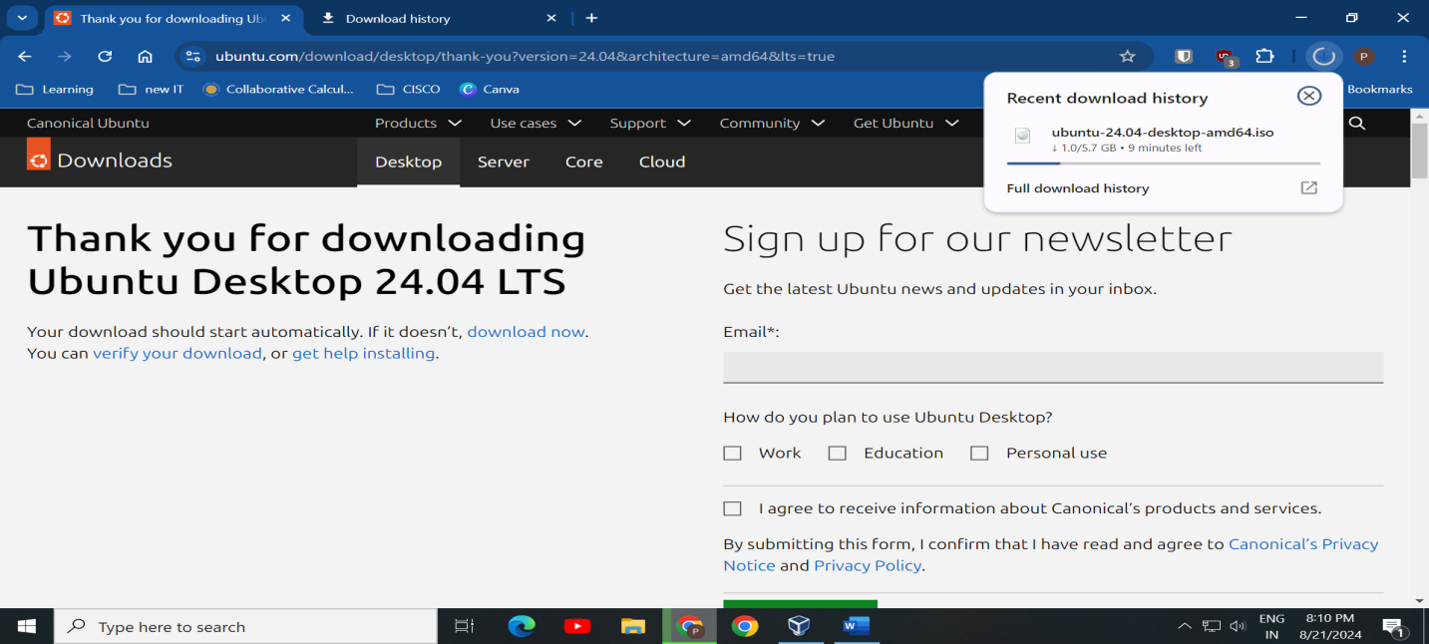

**Step 2:**

**BACKUP YOUR DATA**

The second step is to backup your data before installing a new OS. This is very important, as you may lose some or all of your files during the installation process, depending on the type and method of installation. You can backup your data to an external hard drive, a cloud service, or a flash drive

**Step 3:**

**Create a Bootable USB Drive**

Use a tool like Rufus (for Windows) or Etcher (for Mac and Linux) to create a bootable USB drive from the downloaded ISO file.

**Steps:**

1. Insert your USB drive.
2. Open Rufus or Etcher.
3. Select the Linux ISO file.
4. Select the USB drive.
5. Click "Start" to create the bootable USB.

Here I am using rufus to make my USB drive bootable.

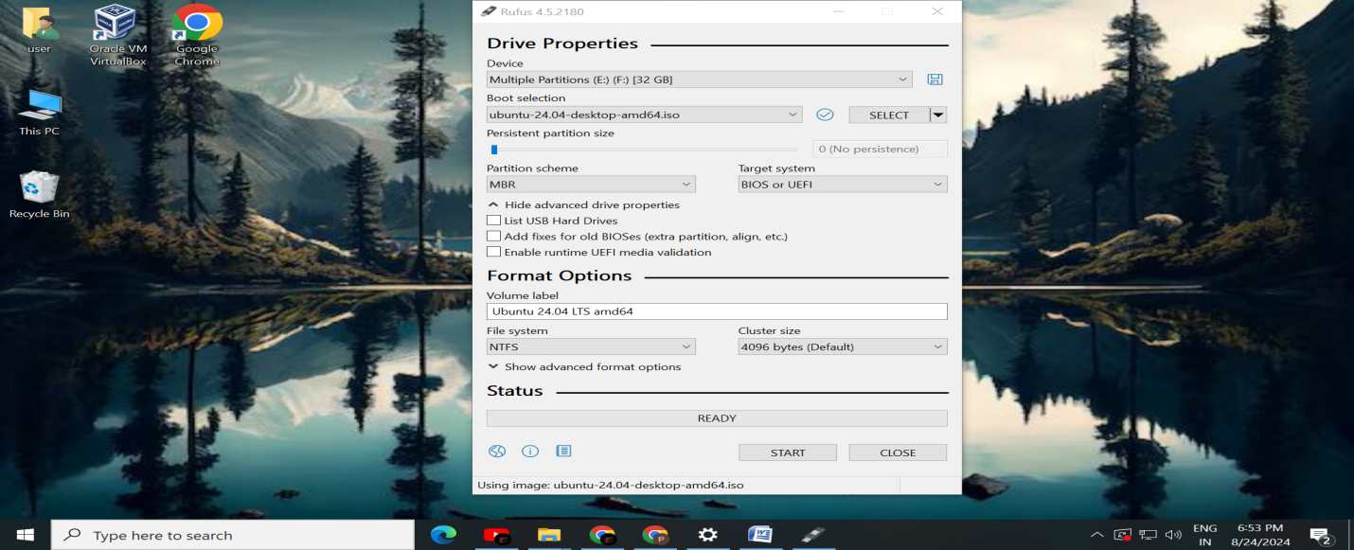

**MBR is the most common format and is compatible with BIOS systems. GPT is a newer type that works with UEFI systems.**

**Here I** have a newer computer with UEFI firmware, (MBR is an older standard that uses the standard BIOS partition table, while GPT is newer and uses the UEFI)

So, The Partition Scheme is **GPT** and target system is **UEFI**

File system: **NTFS** The FAT32 file system cannot store individual files larger than 4 GB, while the NTFS file system can. Compared to FAT32, the NTFS file system has higher disk utilization and can manage disk space more effectively. The read and write speeds of NTFS are also faster than that of FAT32.

**Step 4:**

**Change Boot Order in BIOS/UEFI**Restart your computer.

* Enter the BIOS/UEFI settings by pressing a key during startup (commonly F2, F10, Delete, or Esc).
* Change the boot order to prioritize USB booting.

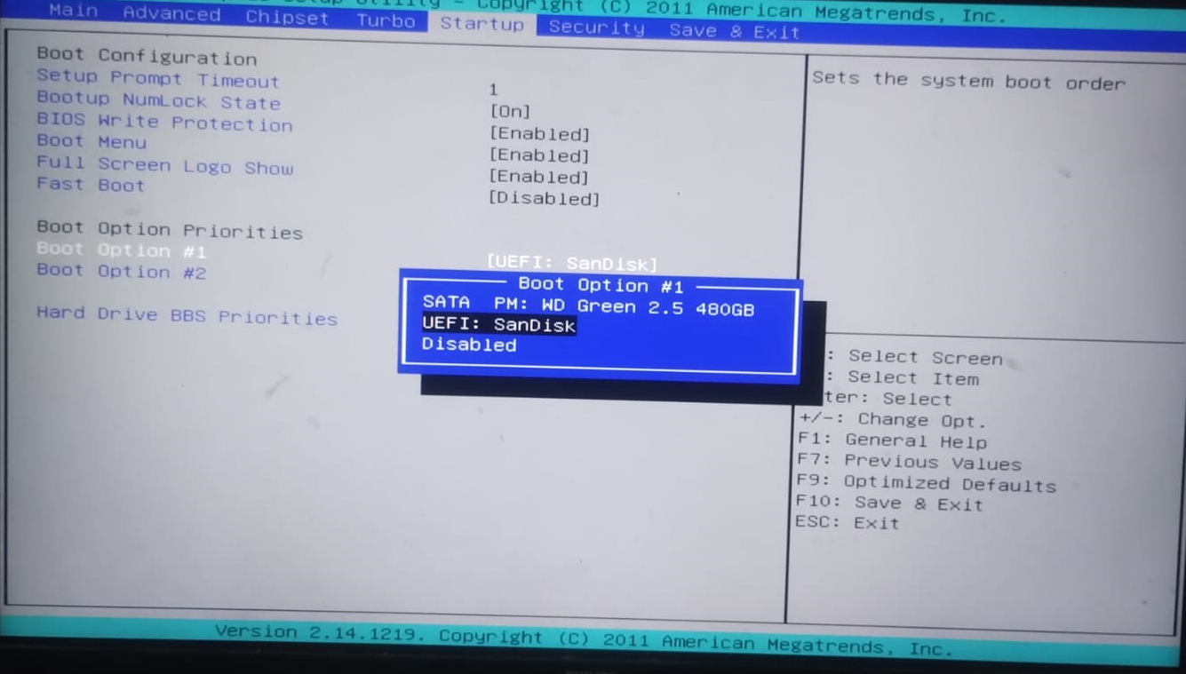

**Step 5:**

**Install Linux**

**Once you entered the boot menu select the USB drive as boot device to start your computer from USB drive.**

**Your computer now boot into ubuntu. Select option: ‘Try or install’ ubuntu and hit enter.**

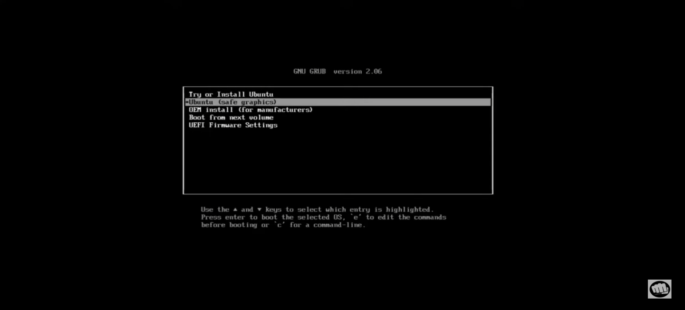

* Follow the on-screen instructions to install Linux.

**Select system language:**

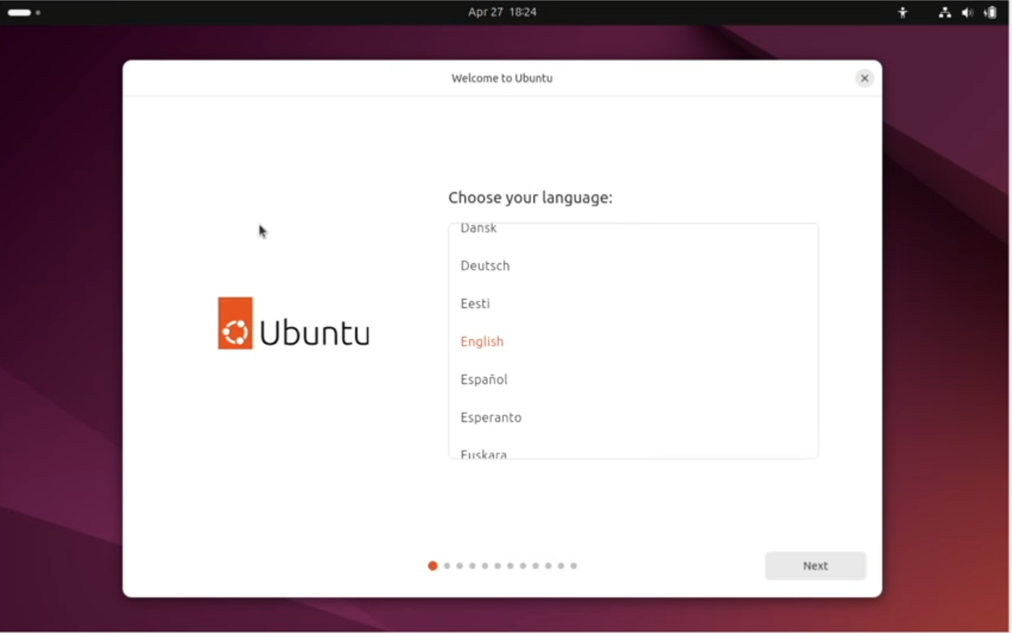

**Select install ubuntu:**

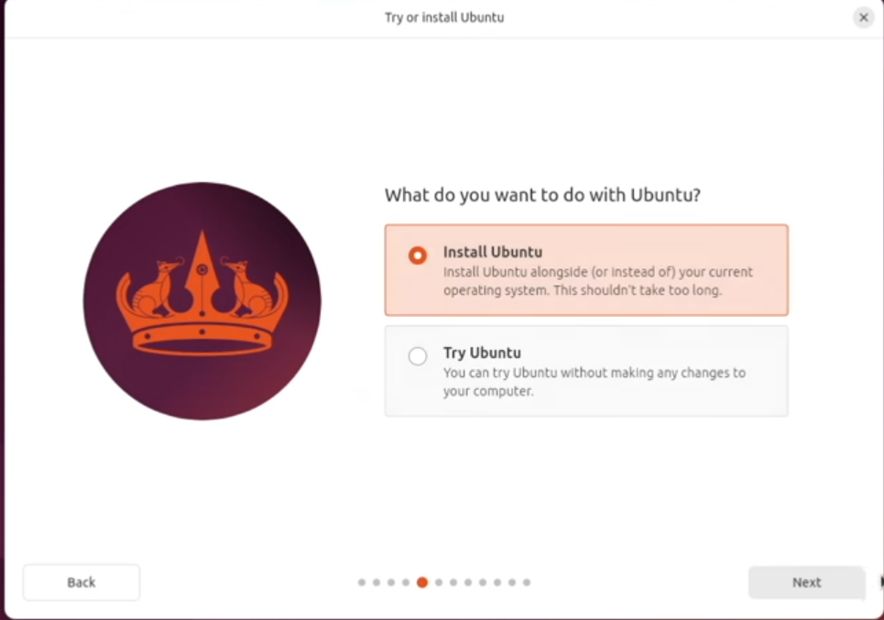

**Select keyboard layout:**

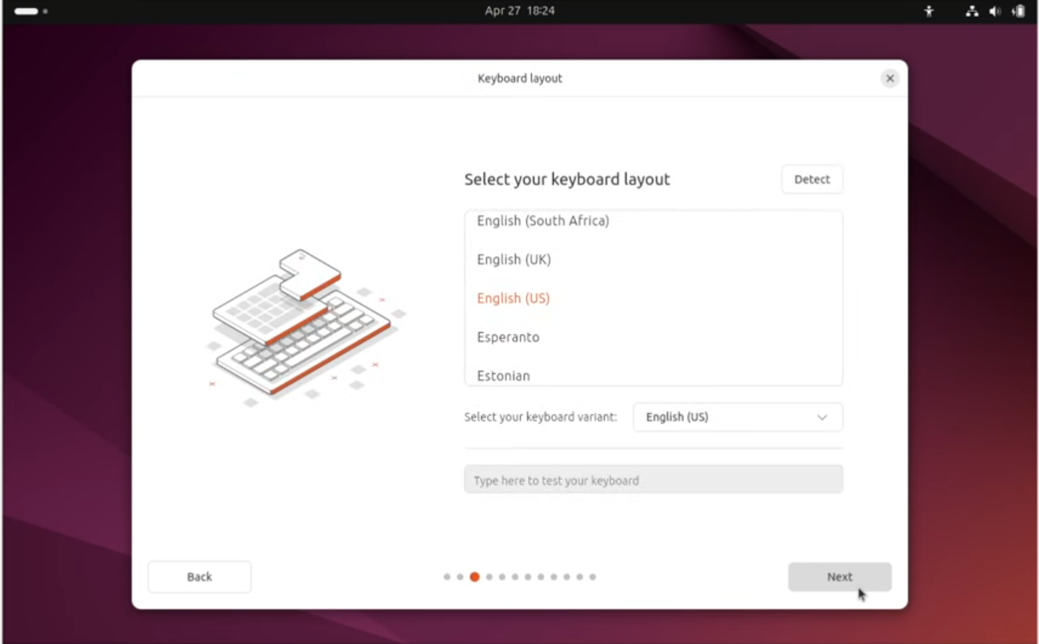

**Select installation type:**

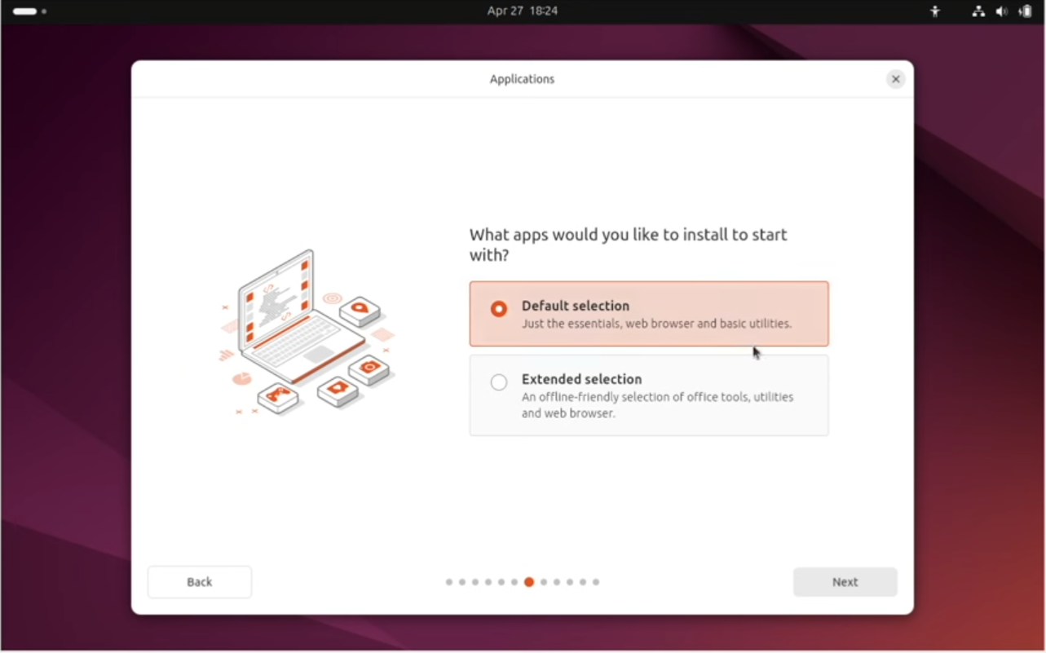

* Choose between:
  + **Erasing the entire disk** and installing Linux (this will delete Windows).
  + **Manual partitioning** if you want more control over the disk layout.

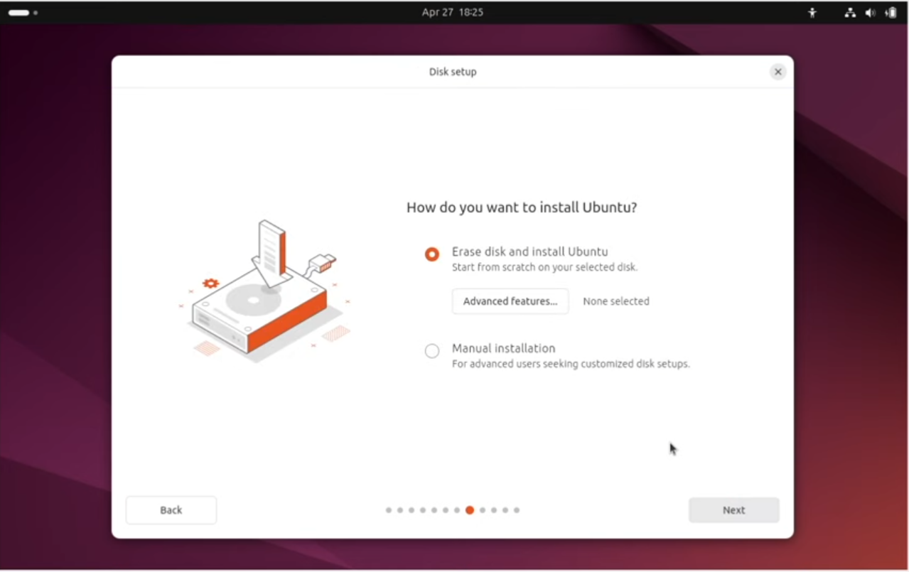

**Complete account set up by giving user name and password:**

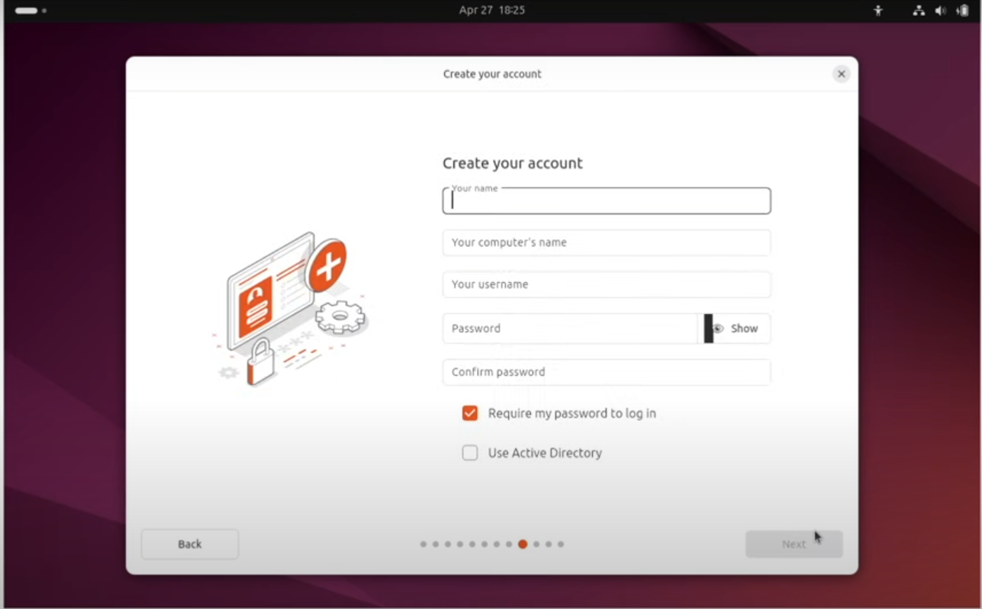

**Step 6:**

**Complete Installation**

* After installation, the system will prompt you to remove the USB drive and restart.
* Upon reboot, you should boot into your newly installed Linux OS.
* If you chose dual-boot, you will see a boot menu where you can choose between Linux and Windows.

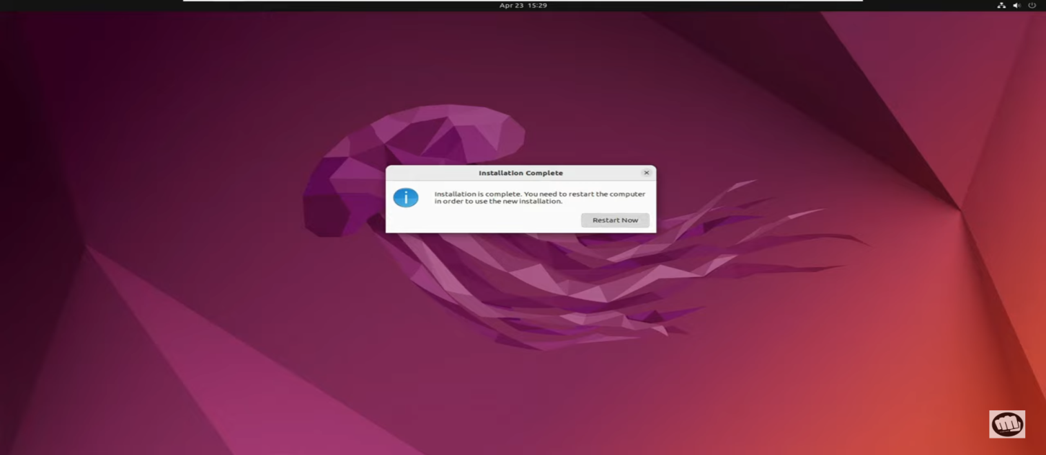

**Step 7:**

### **Post-Installation Setup**

* After logging into Linux for the first time, you might need to update the system, install additional drivers, or software.

### 10. **Explore Linux**

* Now that Linux is installed, take your time exploring and configuring it according to your preferences.